All Saints and All Souls
“Where, O death, is your victory?
Where, O death, is your sting?”
For us Catholics, November is a month to pray for the faithful departed and contemplate the body of Christ and the life of the world to come. We begin a season of colder, shorter days – with a somber, quieter, sort of bare beauty. In this season of dormancy, let us regain the hope for the joyous spring of promise – the promise to be fulfilled “soon, very soon” in Christ – as he returns to us in glory to judge the living and the dead.
To the teens of our parish: Make a point this month to read scripture every day. Go to confession and spend quality time with God alone in prayer.
The world needs the gift of your love. Let the love you receive in Him be that gift you give to others.
Your friend and Youth Minister,
Patrick
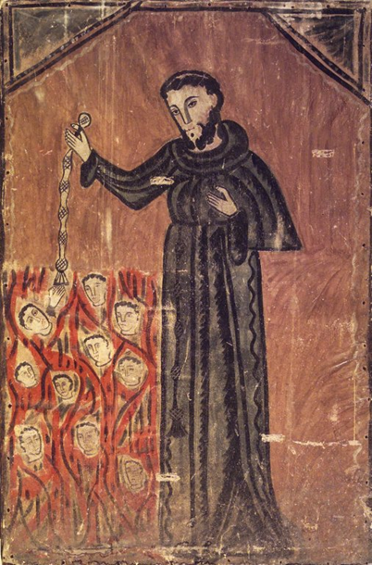
Title
Saint Francis Rescuing Souls from Purgatory
Date
ca. 1805–1850
Geography
Place made: New Mexico, United States
Medium Indian tanned hide, water-based paints

III. The Final Purification, or Purgatory
1030 All who die in God's grace and friendship, but still imperfectly purified, are indeed assured of their eternal salvation; but after death they undergo purification, so as to achieve the holiness necessary to enter the joy of heaven.
1031 The Church gives the name Purgatory to this final purification of the elect, which is entirely different from the punishment of the damned.⁶⁰⁴ The Church formulated her doctrine of faith on Purgatory especially at the Councils of Florence and Trent. the tradition of the Church, by reference to certain texts of Scripture, speaks of a cleansing fire:⁶⁰⁵
As for certain lesser faults, we must believe that, before the Final Judgment, there is a purifying fire. He who is truth says that whoever utters blasphemy against the Holy Spirit will be pardoned neither in this age nor in the age to come. From this sentence we understand that certain offenses can be forgiven in this age, but certain others in the age to come.

